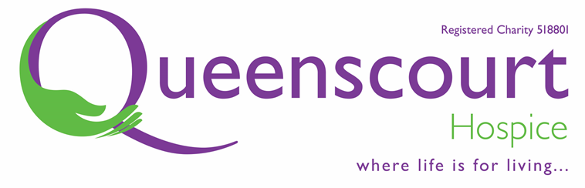
2024 SPRING RAFFLE
Draw held at Queenscourt Hospice on
Thursday 13th June 2024.

WINNERS!
 | Ticket No. |  | Ticket No.
1st PRIZE £2000 | 118316 | 3rd PRIZE £20 | 168526
2nd PRIZE £200 | 111220 | 3rd PRIZE £20 | 137031
3nd PRIZE £20 | 150035 | 3rd PRIZE £20 | 157295
3rd PRIZE £20 | 131753 | 3rd PRIZE £20 | 147440
3rd PRIZE £20 | 153409 | 3rd PRIZE £20 | 140516
3rd PRIZE £20 | 100009 | 3rd PRIZE £20 | 137417

THIS YEAR’S WINNER LIVES IN CHURCHTOWN, SOUTHPORT.
We would like to extend a huge thank you to everyone who took part in our Spring Raffle. Your support is greatly appreciated. It enables us to keep Queenscourt in service and to provide an exceptional level of care for local people with life-limiting illnesses when they need us the most.

